Challenge
LO2 – Advising
Malamski,Dimitar D.S.
mitemalamata@gmail.com

Contents
Introduction 2
Sprints 2
Sprint 3 2
Evidence 1 - Advising a Baseline Style-Classification Approach 2
Evidence 2 – Prioritizing Style Over Clothing Type in the First Iteration 2
Evidence 3 – Using the First Model Results to Advise the Next Iteration 3
Sprint 1 & 2 4

Introduction
This document presents the evidence for Learning Outcome 2 ( Advising ) in my Challenge project – Outfit Recommendation System. The purpose of this document is to show how I demonstrated this learning outcome by translating the results of my analysis and experiments into practical recommendations. The evidence is organized by sprint, with each section describing the activity, the result, and why it is relevant to the learning outcome.

Sprints

Sprint 3

Evidence 1 - Advising a Baseline Style-Classification Approach
What this evidence is
This evidence shows how I recommended starting with a baseline style-recognition system before moving to a full recommendation model.
What I did
After discussing the project direction, I agreed with the advice to work iteratively and first build a baseline model that predicts fashion style from an image. This approach was more suitable for the available data and gave me a clear first step that could later support a recommendation system. I then used this idea as the basis for the first notebook I created.
Result
This resulted in a more practical and structured project plan. The baseline model gave me a way to test whether the dataset and style definitions were usable before expanding the project further.
Why this is relevant to the Learning Outcome
This is relevant to Advising because I recommended an analytical approach that fit the project context. Instead of starting with a complex solution, I chose a simpler model that could be used as a foundation for future development.
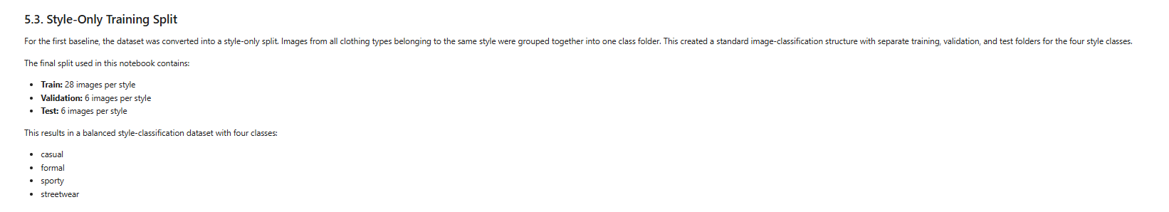

Evidence 2 – Prioritizing Style Over Clothing Type in the First Iteration
What this evidence is
This evidence shows how I advised on the scope of the first model by choosing to use style labels first, while keeping clothing type for later stages.
What I did
Although the dataset was organized using both style and clothing type, I decided to use only style as the prediction target in the first baseline. Clothing type was still included in the dataset structure, because it could be useful later when extending the project toward recommendation. However, for the first iteration, I focused only on style because it was the most relevant and manageable choice for the current analytical task.
Result
This resulted in a more focused model design, where the first task stayed simple while still leaving room for future expansion. It also helped me keep the first baseline clearly separated from later recommendation ideas.
Why this is relevant to the Learning Outcome
This is relevant to Advising because I made a deliberate decision about what to prioritize first in the analytical approach. I did not use all available information immediately, but recommended a narrower scope that better matched the current project stage.

Evidence 3 – Using the First Model Results to Advise the Next Iteration
What this evidence is
This evidence shows how I used the results of the first baseline model to advise the next steps in the project.
What I did
After training and evaluating the first style-classification model, I reviewed the results to see where the model performed well and where it struggled. The model achieved good performance on some classes, especially formal, but it was less accurate for other classes such as streetwear and sporty. I also observed confusion between classes that are visually similar, which showed that some style boundaries in the dataset were still difficult for the model to learn. Based on these results, I concluded that the next iteration should focus on improving class distinction, collecting more data for weaker classes, and refining the style definitions where needed.
Result
This resulted in a clearer direction for the next stage of the project. Instead of continuing with the same setup unchanged, I used the model outcomes to decide what should be improved first in order to make the system more reliable.
Why this is relevant to the Learning Outcome
This is relevant to Advising because I translated analytical results into a practical recommendation for the next iteration. The model evaluation did not only show performance, but also provided insight into what changes were needed to improve the analytical approach.
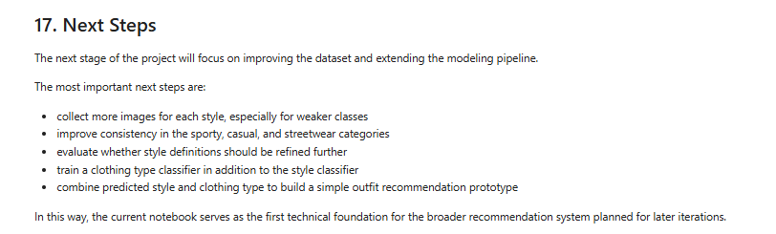

Sprint 1 & 2
There was no work done in those sprints, since the projects starts from Sprint 3.

